Femur Musculoskeletal Stress Markers on UAG66

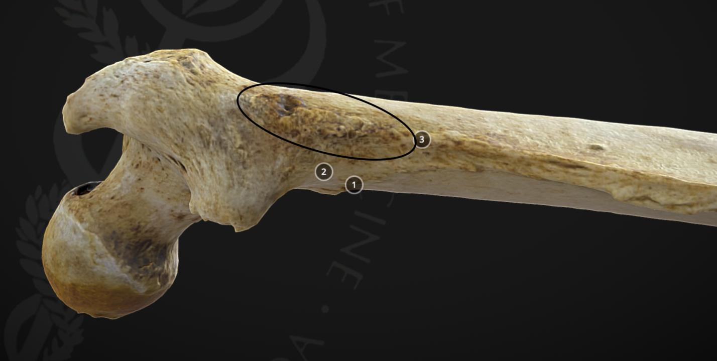

1 Gluteal tuberosity (just the oval not numbers for this one)

Muscle – gluteus maximus (insertion)

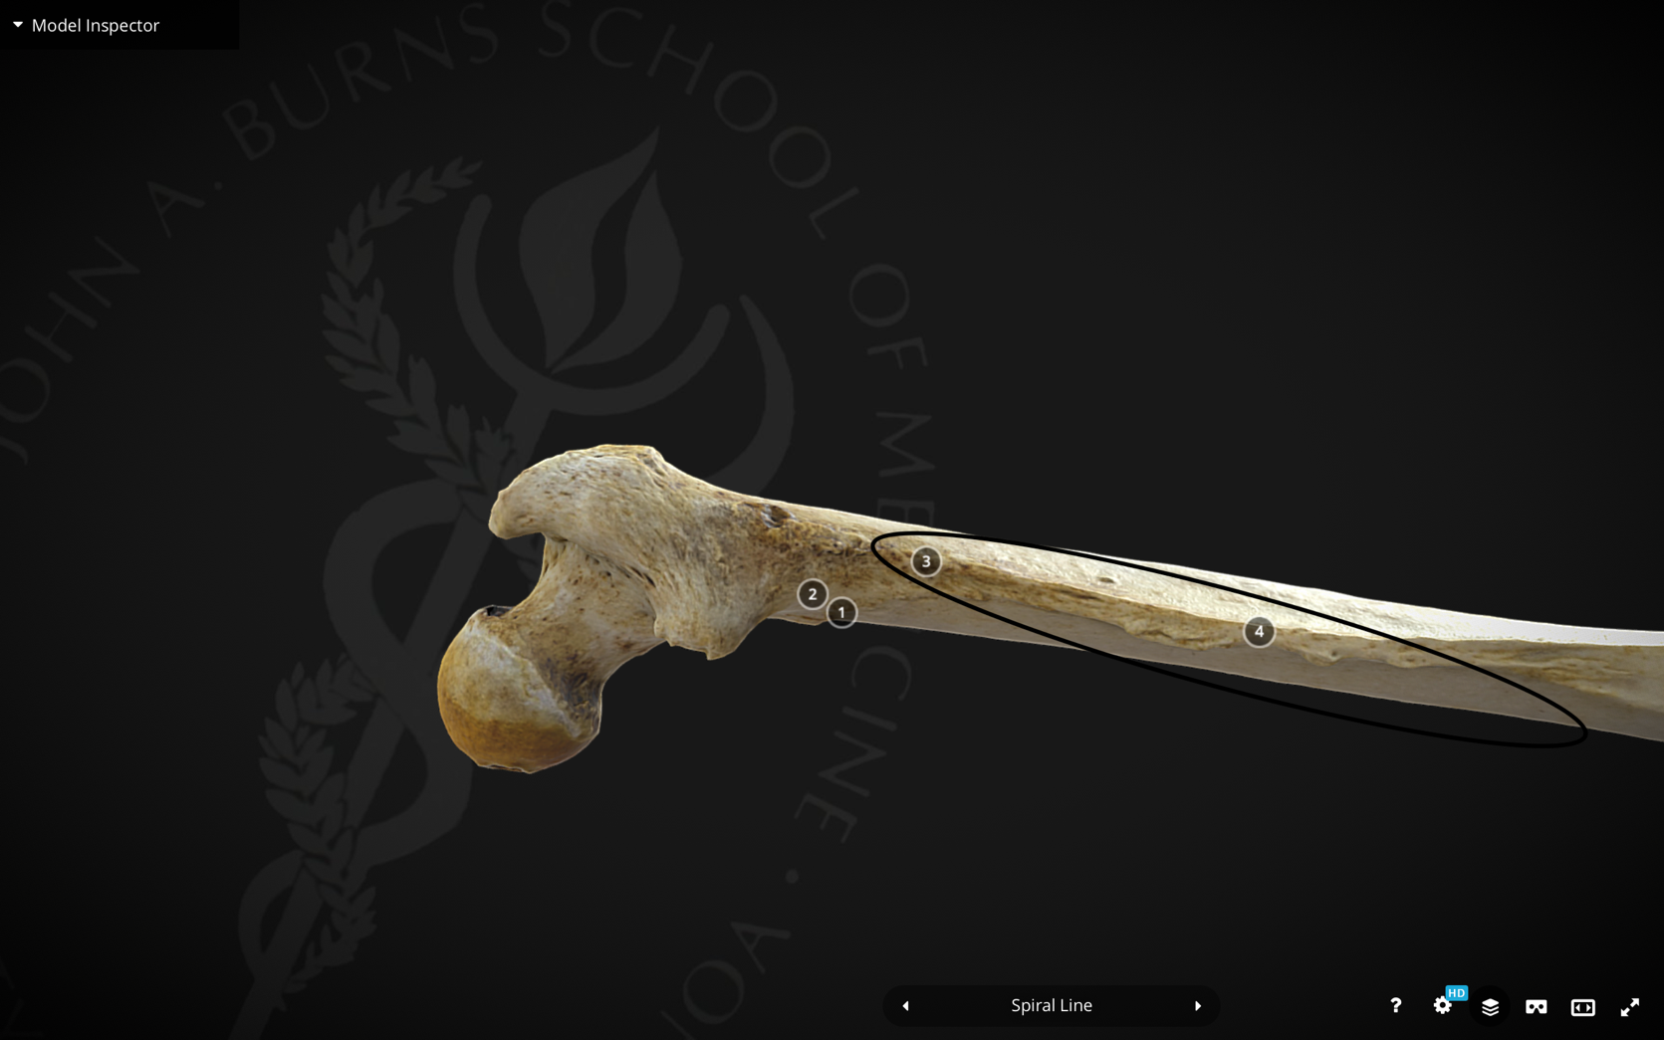

2 Linea aspera (just the oval not the numbers for this one)

Muscle – Adductor magnus (insertion)

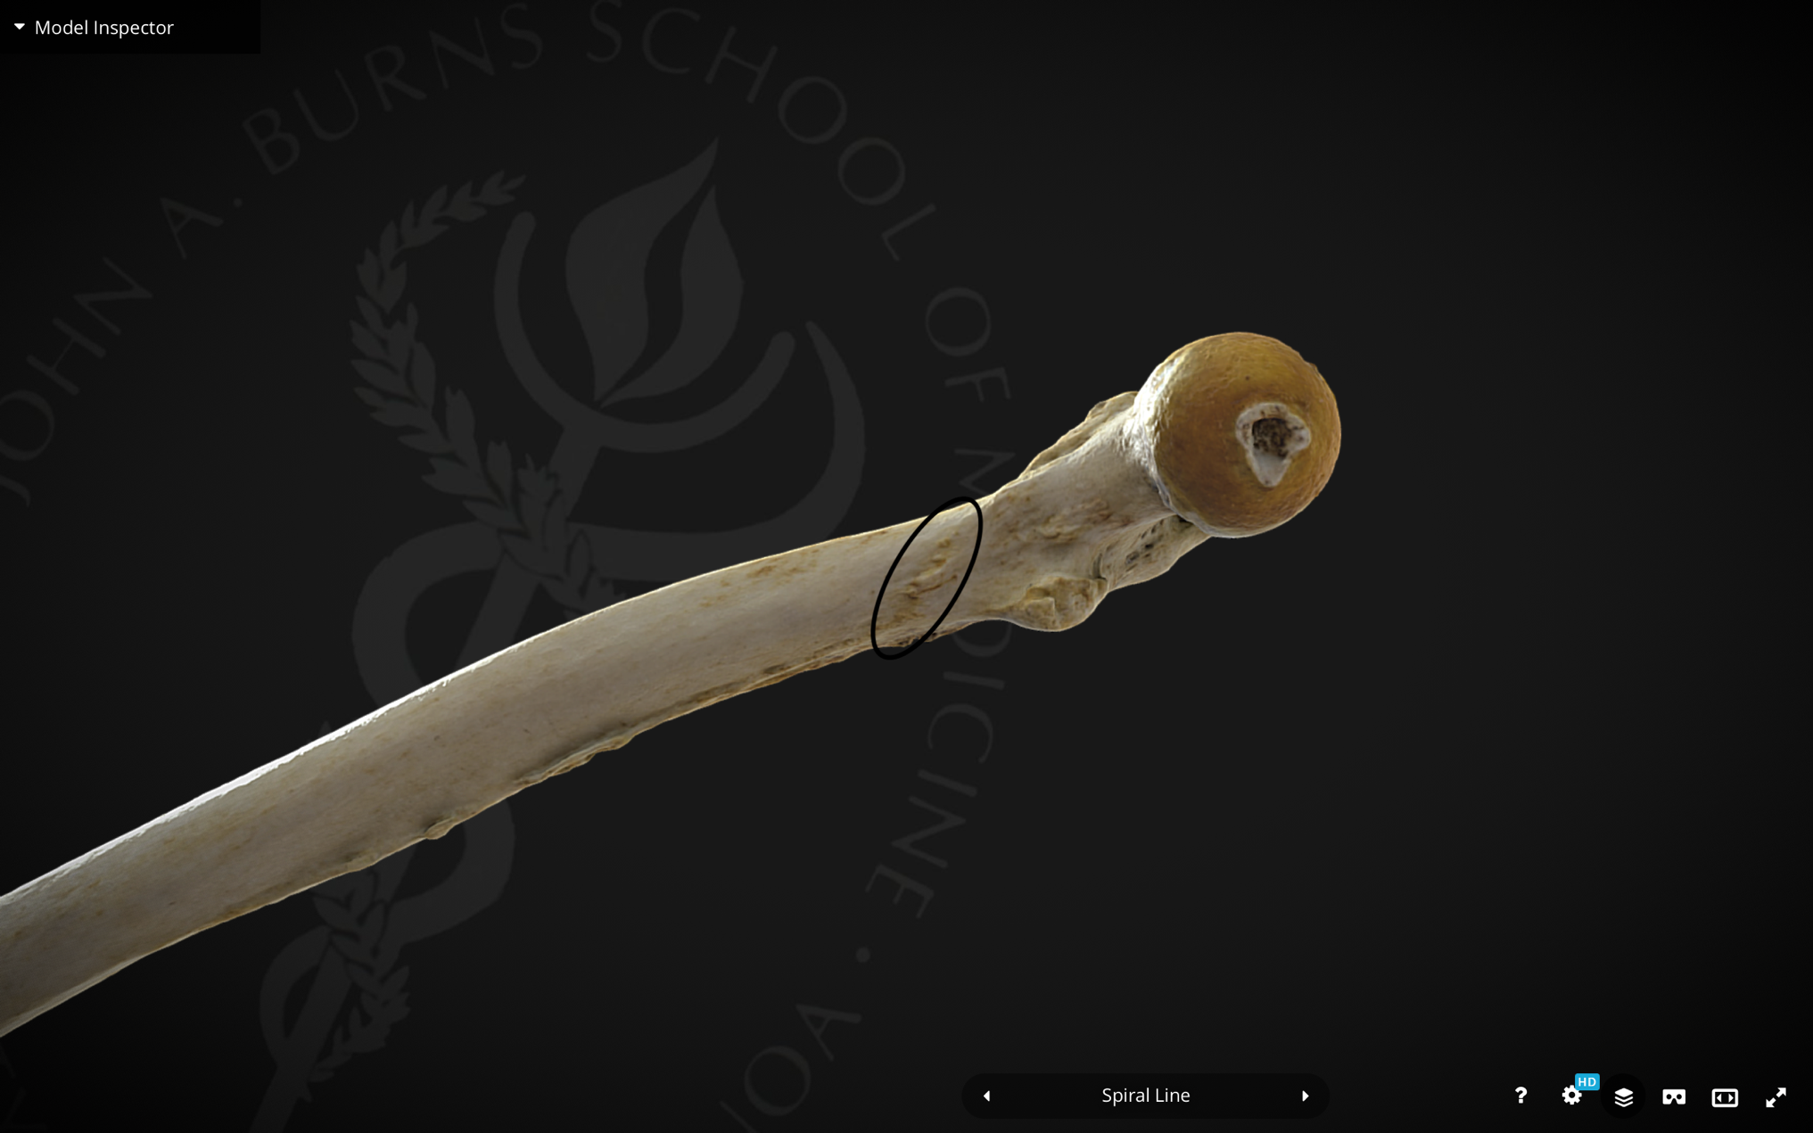

3 Proximal, medial surface

Muscle – Vastus medialis (origin)

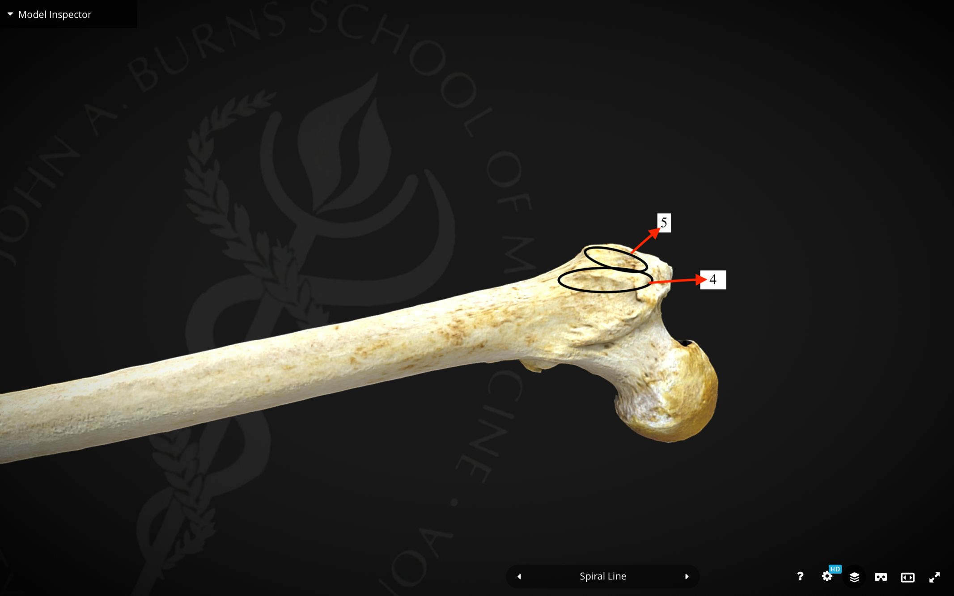

4 Anterior greater trochanter

Muscle – Vastus lateralis (origin)

5 Anterolateral greater trochanter

Muscle – Gluteus minimus (insertion)

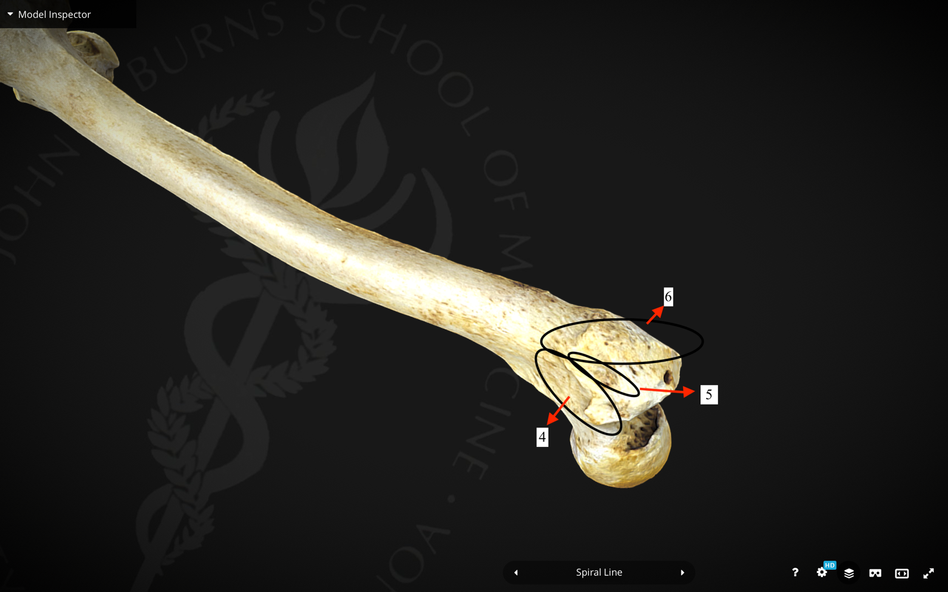

6 Lateral greater trochanter

Muscle – Gluteus medius (insertion)

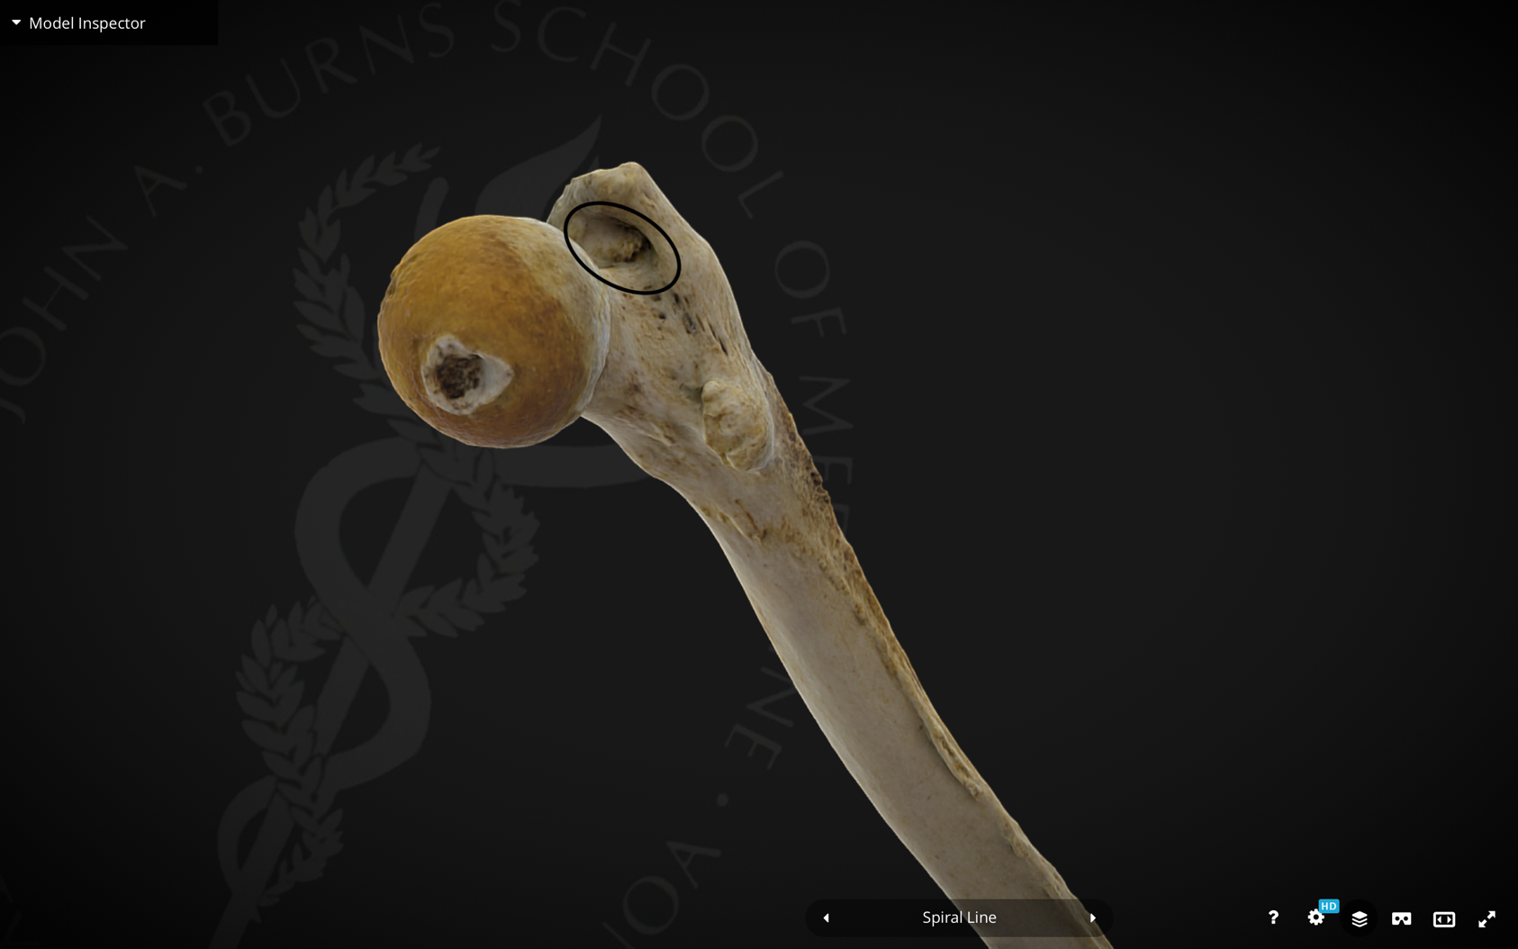

7 Trochanteric fossa

Muscle – Obturator externus (insertion)

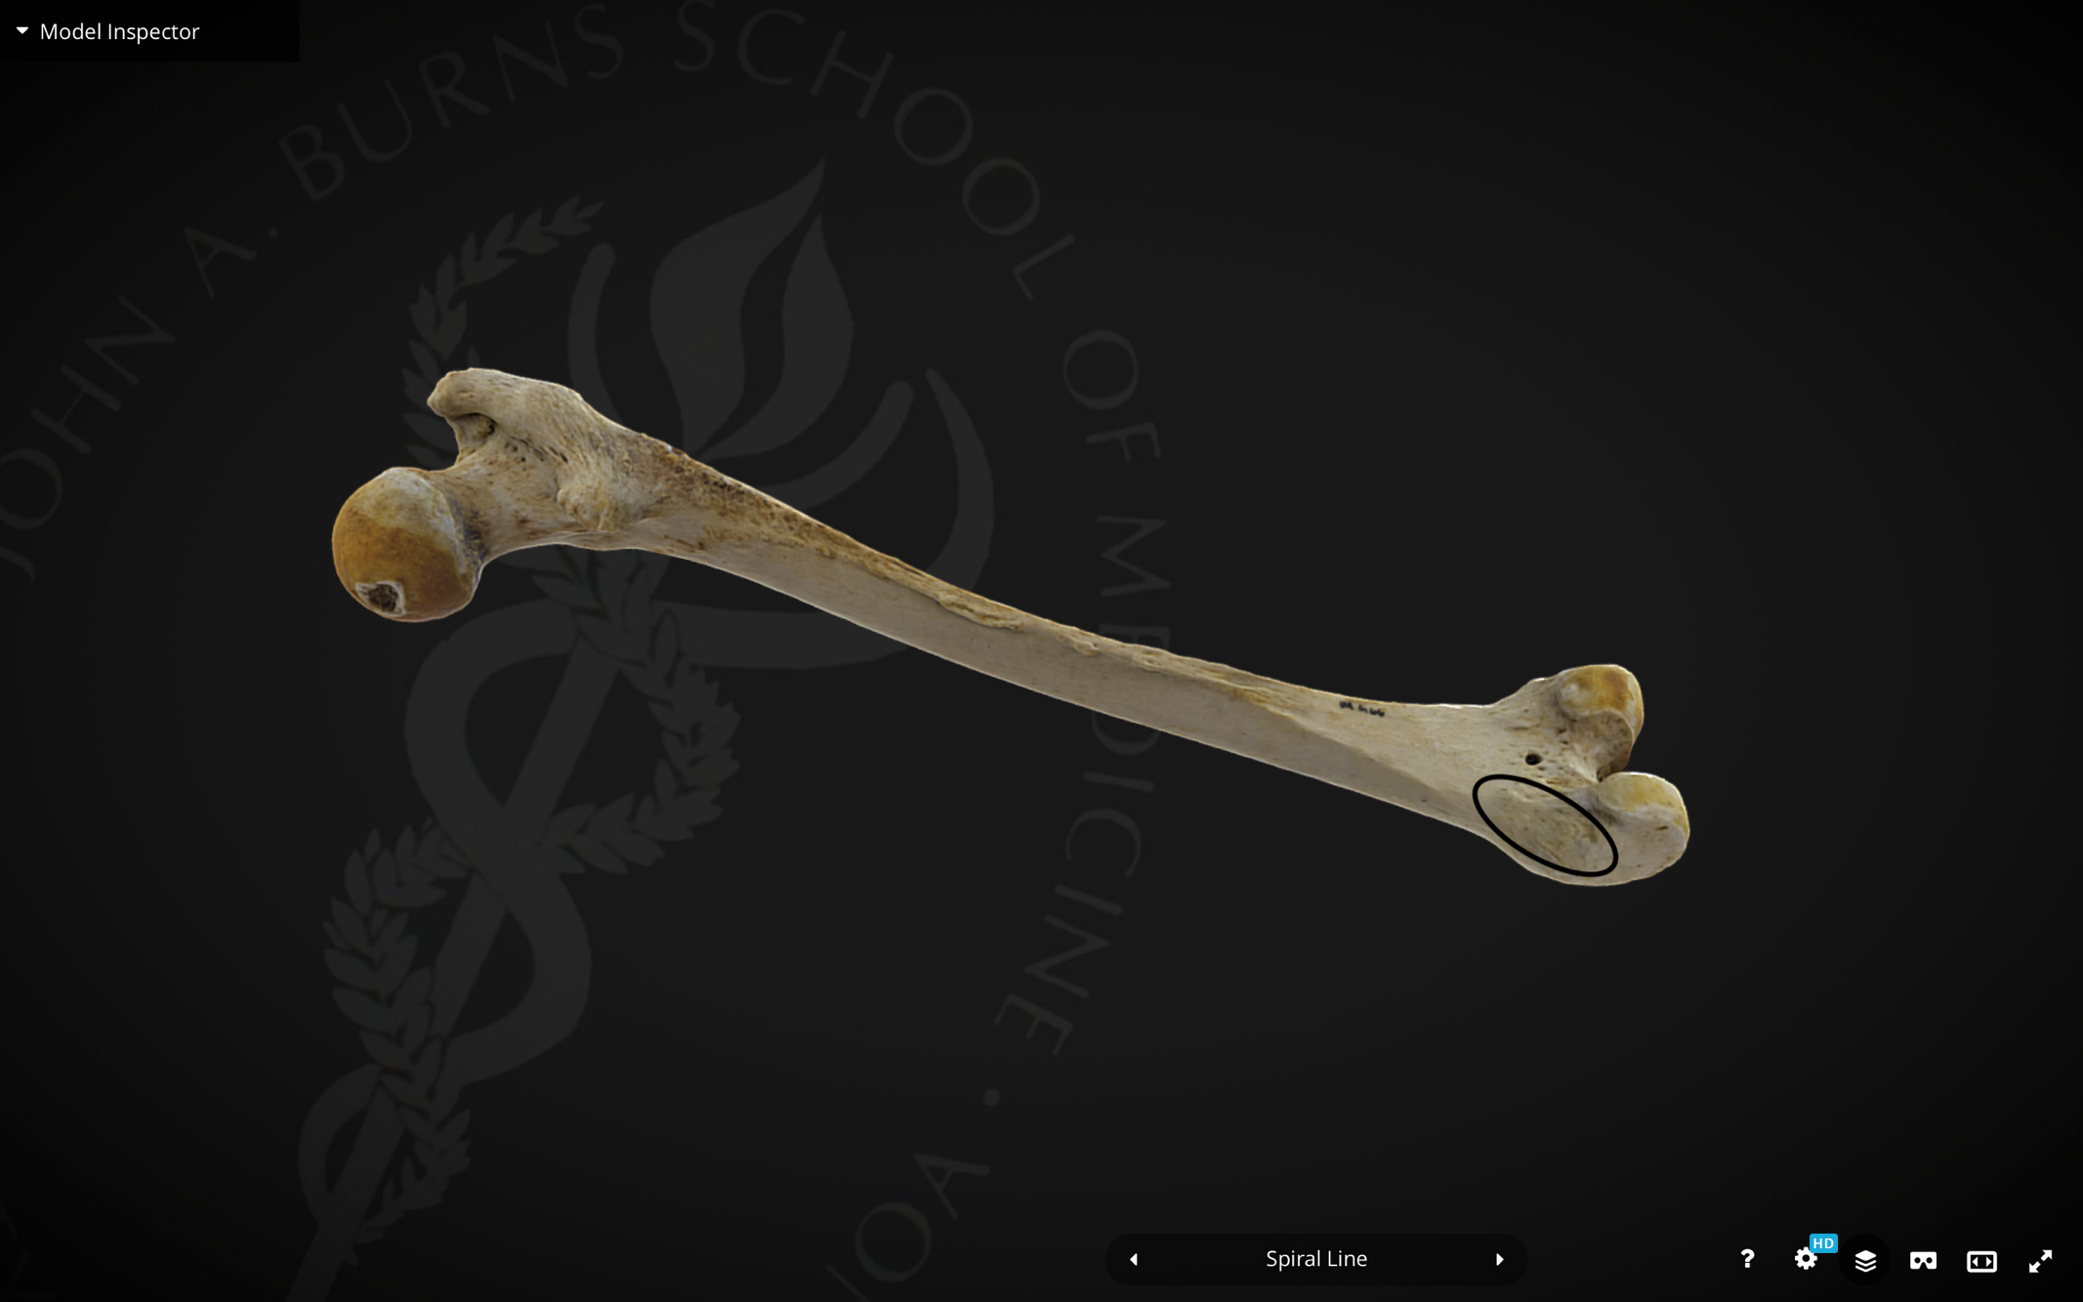

8 Medial epicondyle

Muscle – Gastrocnemius (origin -medial head)

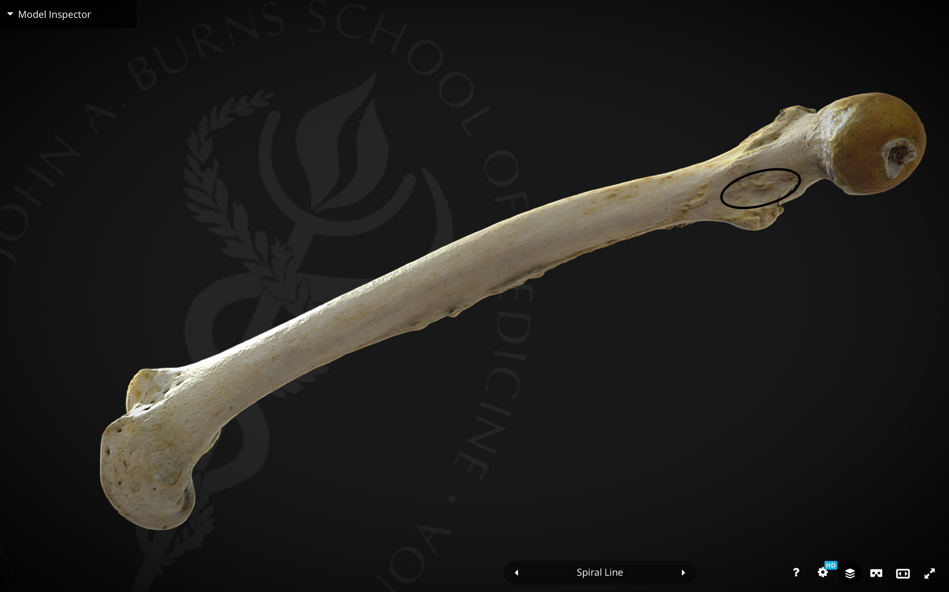

9 Lesser trochanter (base)

Muscle – Iliacus (insertion)

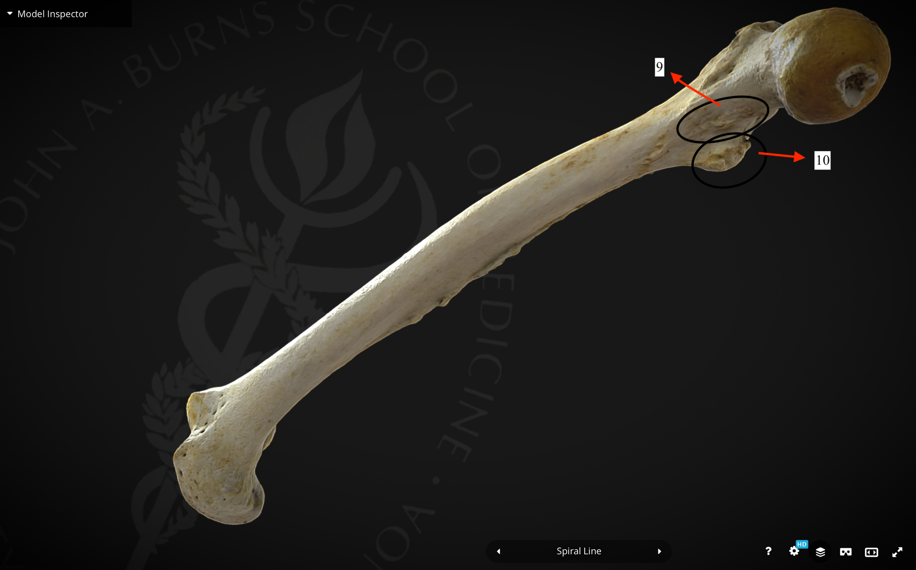

10 Lesser trochanter

Muscle – Soleus (origin)